University of Engineering and Technology, Lahore
Name: Maria Abbas
Reg No: 2026(S) CYS_61
Department: Computer Engineering
Degree: Cyber security
Section: B
Assignment: PF Lab week 5
Date: 30 March 2026
CLO2

Lab Tasks
Functions
Task 1:
This program uses Python's built-in len() function to calculate the total number of characters in a string. It shows how a function takes an input value and returns its size to be stored and printed.
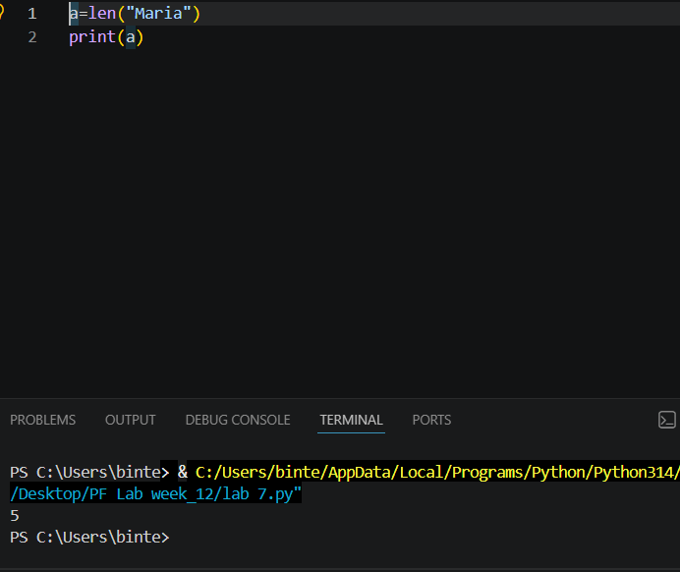
Task 2:
This program uses Python's built-in max() function to find the largest number from a given group of values. It compares the numbers and returns the highest value to be saved and printed.
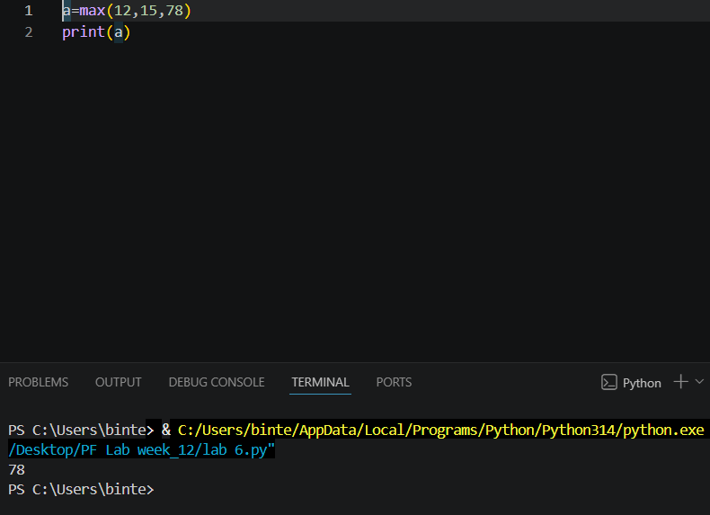
Task 3:
This program uses a custom user-defined function called fact() to calculate the factorial of a number. It then reuses this function to compute and display mathematical permutation and combination values based on user input.
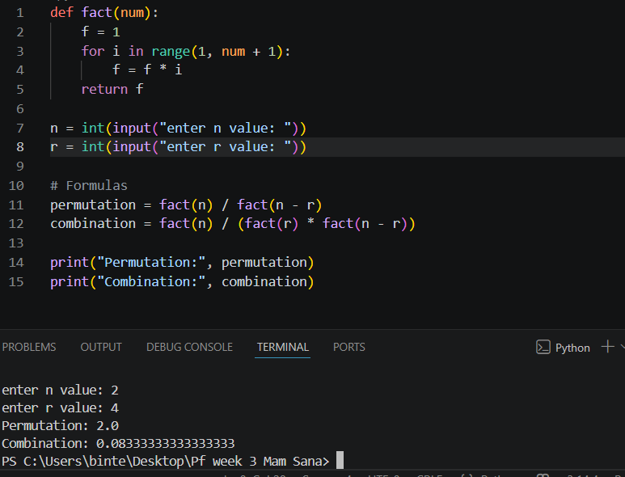

Task 4:
This program uses a lambda function to convert text to uppercase and a user-defined function to reverse it. It demonstrates how to modify and flip an input string step by step.
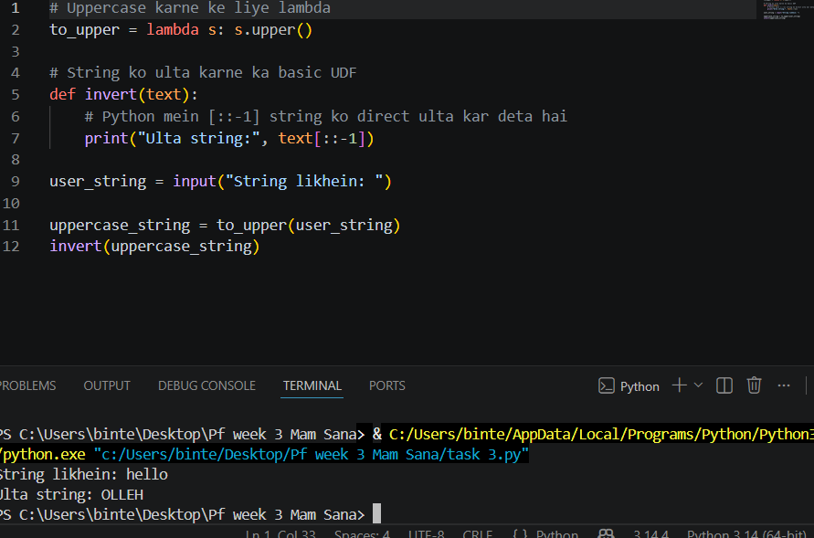
Task 5:
This program uses two user-defined functions to convert temperatures between Celsius and Fahrenheit. It shows how to pass user input into mathematical formulas to calculate and return the converted results.
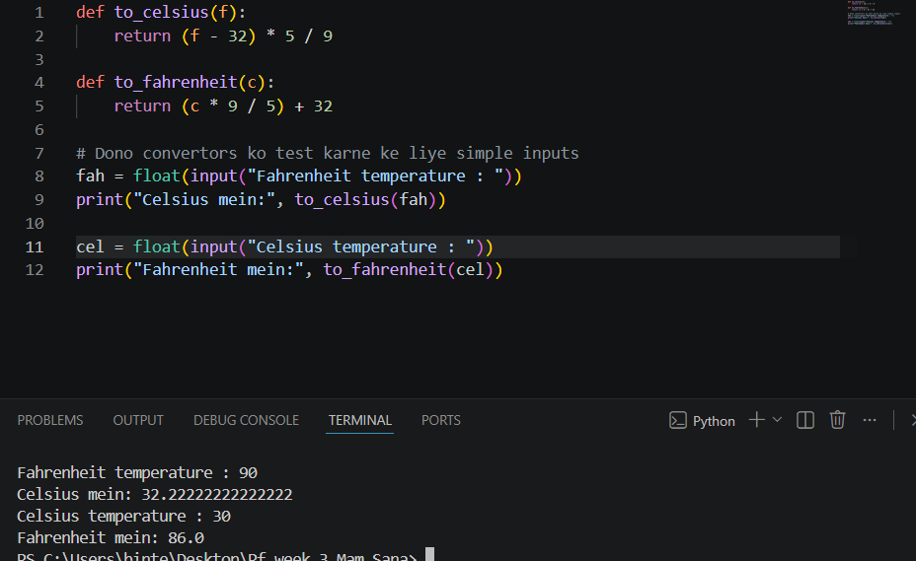
Task 6:
This program uses a user-defined function and a for loop to calculate a student's total GPA for the semester. It loops through each subject to take grade points and credit hours, then uses the GPA formula to print the final result.
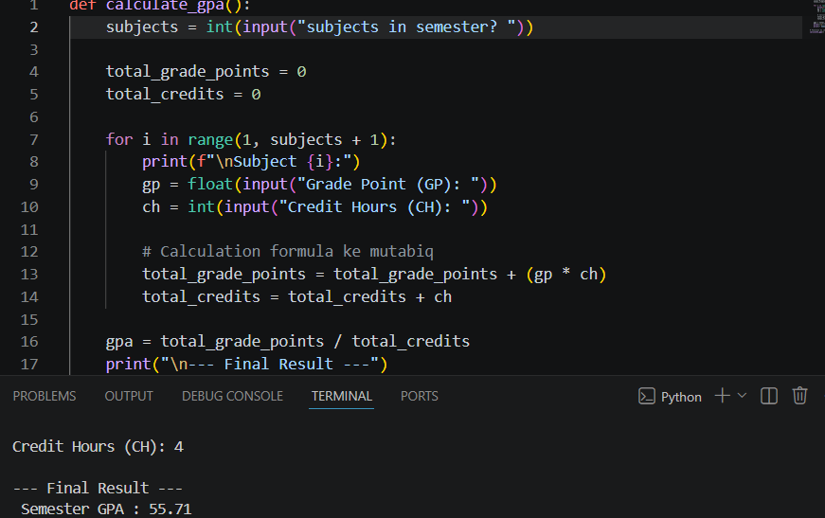
Task 7:
This program uses a simple user-defined function called add() to calculate the sum of two numbers. It takes two integers as input from the user, passes them into the function, and prints the total sum.
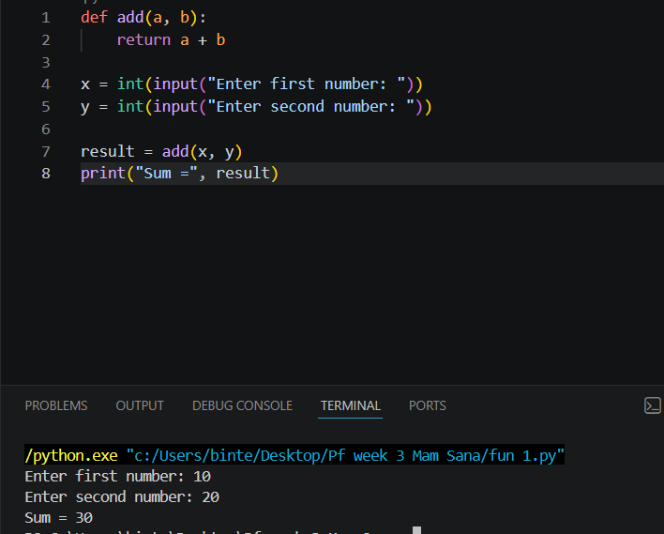
Task 8:
This program uses a user-defined function called square() to calculate the mathematical square of a number. It takes an integer input from the user, multiplies it by itself, and returns the result to be printed.
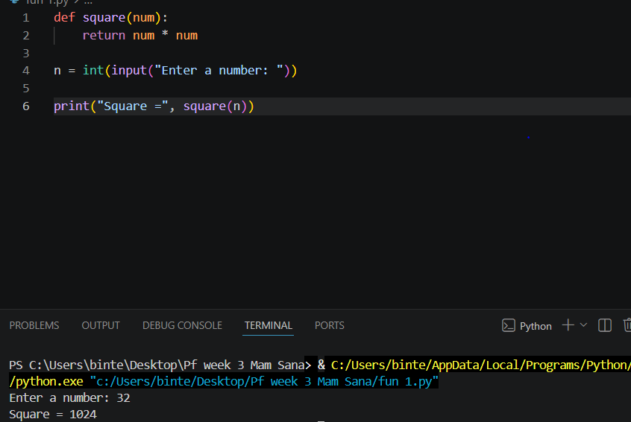

Task 9:
This program uses a user-defined function combined with an if-else condition to check whether a number is even or odd. It uses the modulus operator (%) to determine if the number is perfectly divisible by 2.
